**Project Based Learning (PBL) Report**

**On**

E-POLICE

B.Tech. 3rd Year, Section A

Session: 2020-2021

Submitted By

**Kunal Sagar (2018013500)**

**Simran Chauhan (2018014397)**

**Ayush Maurya (2018001707)**

**Vishal Sachan (2018011898)**

**Submitted To: Mr. Manish Verma**



Sharda University

School of Engineering and Technology

Department of Computer Science and Engineering

November 2020

**DECLARATION**

I hereby declare that the project entitled **“E-POLICE**” submitted for the course of B.Tech Project Based Learning (PBL) Project is my original work. I have adequately cited and referenced the original sources. I also declare that I have adhered to all principles of academic honesty and integrity and have not misrepresented or fabricated or falsified any idea/data/fact/source in my submission. I understand that any violation of the above will be cause for disciplinary action by the Institute and can also evoke penal action from the sources which have thus not been properly cited or from whom proper permission has not been taken when needed.

**Kunal Sagar**

**Simran Chauhan**

**Ayush Maurya**

**Vishal Sachan**

**Place:**

**Date:**

**CERTIFICATE**

It is certified that the work contained in the project report titled “E-POLICE” by “Kunal Sagar, Simran Chauhan, Ayush Maurya and Vishal Sachan” has been carried out under my supervision and that this work has not been submitted elsewhere.

**Mr. Manish Verma**

**Place:**

**Date:**

**Acknowledgement**

It is our privilege to express our sincerest regards to our project coordinator, Mr. Manish Verma for their valuable inputs, able guidance, encouragement, whole-hearted cooperation and constructive criticism throughout the duration of our project.

We deeply express our sincere thanks to our Head of Department Dr. Nitin Rakesh for encouraging and allowing us to present the project on the topic “E-POLICE” at our department premises for the partial fulfilment of the requirements leading to the award of B-Tech degree.

We take this opportunity to thank all our lecturers who have directly or indirectly helped our project. We pay our respects and love to our parents and all other family members and friends for their love and encouragement throughout our career. Last but not the least we express our thanks to our friends for their cooperation and support.

**Abstract**

* We will be starting an “E-POLICE” app. Through which any victim can file a FIR or lodge any online complaint.
* Also, users will be able to track their previous filled FIR.
* There will be a location feature through which the nearest police station will come into action as the FIR will be under their control.
* There will be a proper verification of the person who is filing the FIR.

**Functionalities:**

* E-FIR
  + OTP login
    - FIR form - authenticate with face id.
    - Check previous FIR status.
* Nearby Police station
  + show nearby police station according to user location.
* Important laws, rules and helpline numbers.

**Table of Contents**

|  |  |  |
| --- | --- | --- |
|  |  |  |
|  | Title Page |
|  | Declaration of the Student |
|  | Certificate of the Guide |
|  | Abstract |
|  | Acknowledgement |
|  | List of Tables (optional) |
|  |  |
| **1.** | **INTRODUCTION** |
|  | * 1. Brief of PBL   2. Group formation   3. Problem identification   1.4 Hardware and software specification |
|  |  |
| **2.** | **PROJECT DESIGN** |
|  | 2.1 Workflow/Block-diagram  2.2 Algorithms and Pseudo Code |
|  |  |
| **3.** | **PROJECT IMPLEMENTATION** |
|  | 3.1 Coding |
|  |  |
| **4.** | **RESULTS / OUTPUTS** |
| **5.** | **CONCLUSIONS / RECOMMENDATIONS** |

**WEEK-0**

**Brief of PBL (Project Based Learning)**

Project-based learning is a dynamic classroom approach in which students actively explore real-world problems and challenges and acquire a deeper knowledge.

Project Based Learning (PBL) is an instructional methodology that encourages students to learn and apply knowledge and skills through an engaging experience. PBL presents opportunities for deeper learning in-context and for the development of important skills tied to college and career readiness.

**Characteristics of Project Based Learning**

Here are three characteristics of meaningful project-based learning activities that lead to deeper student understanding:

**1.) Inter-disciplinary**

PBL focuses on engaging students with real-world problems. This is an interdisciplinary approach because real-world challenges are rarely solved using information or skills from a single subject area. Projects require students to engage in inquiry, solution building, and product construction to help address the real-world issue or challenge presented. As students do the work, they often use content knowledge and skills from multiple academic domains to successfully complete the project.

**2.) Rigorous**

Project based learning requires the application of knowledge and skills, not just recall or recognition. Unlike rote learning that assesses a single fact, PBL is more complex and can be used to assess how students apply a variety of academic content in new contexts. As students engage in the work of a project, they follow a process that begins with inquiry. Inquiry leads to deeper learning, not just related to academic content, but also related to the use of content in real world applications. Inquiry processes can help lead to the development of solutions that address the problem/challenge of the project and the creation of products to communicate solutions to an audience based upon the application of content and skills.

**3.) Student-centred**

In PBL, the role of the teacher shifts from content-deliverer to facilitator/ project manager. Students work more independently through the PBL process, with the teacher providing support only when needed. Students are encouraged to make their own decisions about how best to do their work and demonstrate their understanding. The PBL process fosters student independence, ownership of his/her work, and the development of 21st century/workplace skills.

**WEEK-1**

**Group Formation:**

The group formed for out project consists of people with different background with different life experiences, come together to identify a common problem and together come up with a unique and viable solution which we will implement.

They members of the group are:

1. Kunal Sagar

System ID: 2018013500

Roll No: 180101168

1. Ayush Maurya

System ID: 2019006264

Roll No: 180101084

1. Simran Chauhan

System ID:2018014397

Roll No: 180101323

1. Vishal Sachan

System ID: 2018011898

Roll No: 180101373

**Problem Identification**

1. The existing system is not responsive and user friendly to use.
2. The existing system is time consuming.
3. As we are focusing more and more on Digitizing India, this will be a good step towards it.

**WEEK-2**

**Hardware / Software Requirement:**

Back-end:

* Database is handled primarily by Google’s firebase for main development and testing of the android app.
* Firebase ML vision kit for face recognition.

Front-end:

* Flutter will be used for front-end development.

**WEEK-3**

**P0: First Presentation**

Presentation for the approval of Project Title.

**WEEK-4**

**A work flow or block diagram for the proposed system / software:**

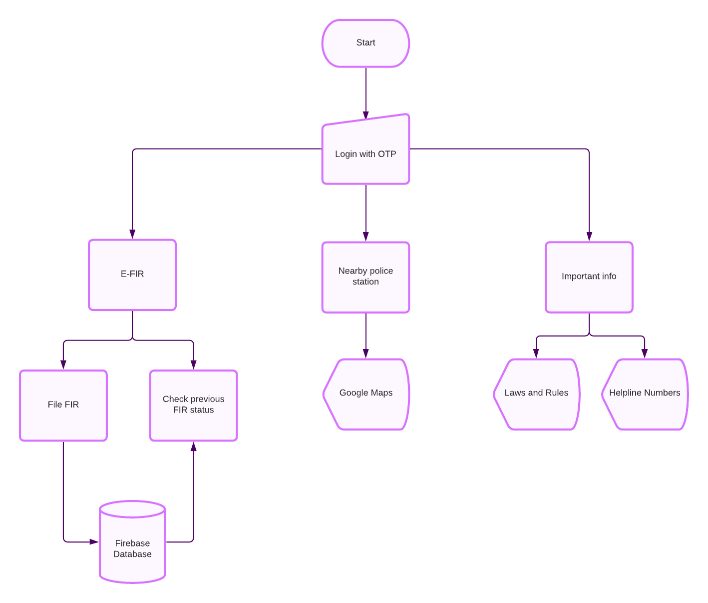

**ER DIAGRAM**

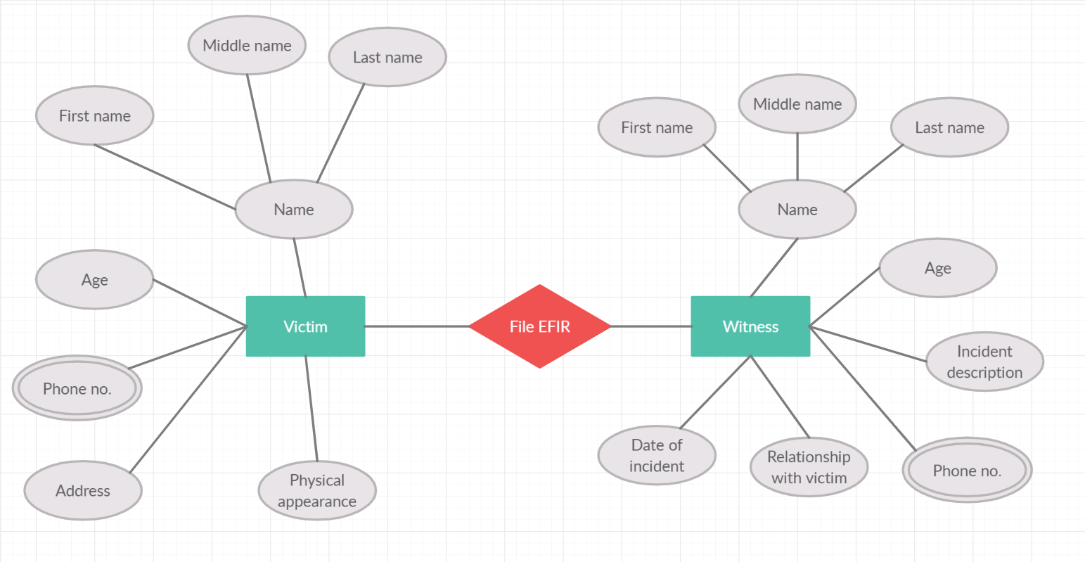

**Week-5/6**

**Algorithm for the proposed system**

1. Setup VSCODE or Android Studio for Flutter development and register the project on firebase.
2. Get Google's places api key.
3. Add all the dependencies and api key required for firebase authentication and google maps api.
4. Create the Dart files for the Home, Login and Splash Screen UI.
5. Create a Dart file for getting the Nearby Location of user and showing all the nearby police stations.
6. Add permissions to read location in the Android Manifest file.
7. Create a Dart file for Checking FIR Status UI.
8. Create a Dart file for connecting firebase with the app.
9. Create a Dart file for showing important helpline numbers and rules.

**Week-7**

Project Design Approval

**Week- 8**

MID SEMESTER EXAMS

**Week-9/10/11**

**Implementation Details**

|  |  |
| --- | --- |
| Figure1: Splash Screen | Figure 2:Login Screen |
| Figure 3:OTP login | Figure 4:Homescreen |
| Figure 5:File FIR | Figure 6:Check FIR Status |
| Figure 7:Nearby Police Stations | Figure 8:Must know rules |

|  |  |
| --- | --- |
| Figure 9:Important Helplines | Figure 10:Save FIR form |

**Week-12**

Project Implementation Reviews

**Week-13/14**

**Testing the Project Modules**

The complied project was tested thoroughly using different usage environment like different, operating system, hardware components and different sets of data. The application was found to be working conveniently. However, latest version of the browsers, operating system and hardware components of the computer are recommended for best results.

**Week-15**

Result Review

**The Conclusion**

During our 15 weeks of PBL, we got to learn a lot including project management, creating new solutions, thinking out problems, team work etc. We also figured out how to bring an imagination to reality using step-by-step and a procedural approach. We would also like to thank our assigned faculty: Mr. Manish Verma Sir, who helped us in all phases of this project and made this idea a reality. In conclusion, we would just say that all of these weeks helped us in shaping our future in a major way.